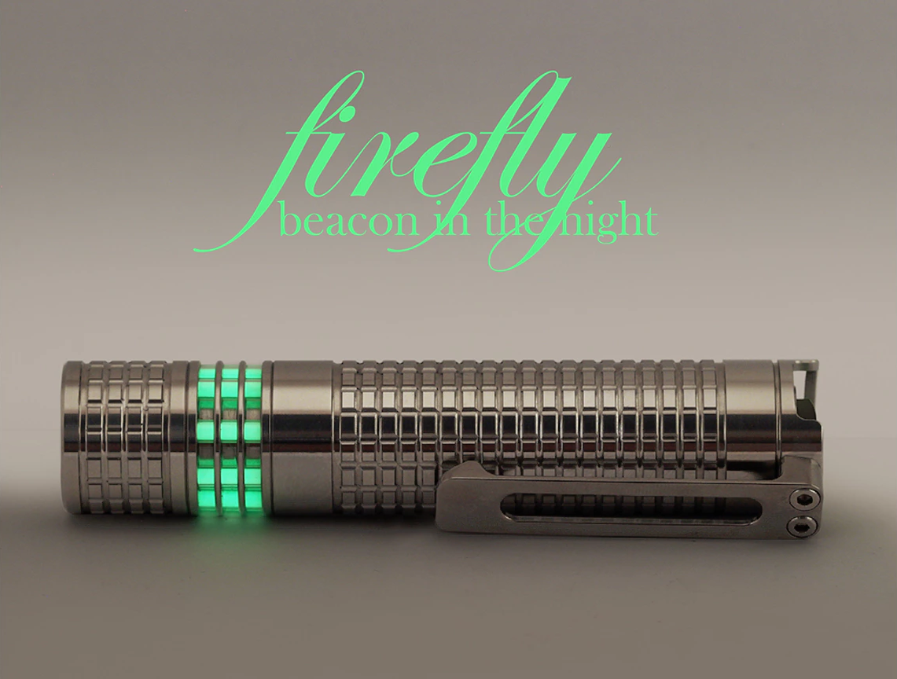firefly

Manual and Information

Revision 155 ·

Contents

Background 3

Recognition 3

Instructions 4

Getting Started 4

Battery Options 5

Modes 6

Maintenance 7

Lube 8

Information 9

Device Details 9

LED Details 9

ANSI FL-1 Standard 10

LED Tests 11

Diagrams 12

Parts 13

Tips, Tricks and FAQ 14

Installing Tritium (GTLS) Tubes 14

Stuck bezel retaining ring 15

Crunchy tail switch 15

Titanium Splinters 18

# Background

Firefly is a titanium flashlight by Joshua Portinga of Portinga Products designed in collaboration with the denizens of CandlePowerForums (CPF). It was originally envisioned for continued production in many metals; Aluminum, Stainless Steel, and Titanium. The original Kickstarter was stopped and relaunched as Firefly 2.0 due to the underwhelming response of metals other than Titanium. Due to the complexity of assembly, which required many steps to be completed by hand, the Firefly won’t see sustained production. This effectively limits this edition to around 300 units.

You may find more information at these sites:

Design <http://www.candlepowerforums.com/vb/showthread.php?403025>  
Kickstarter Campaign <https://www.kickstarter.com/projects/2112614854/firefly-20-a-flashlight-you-can-always-find-in-the>  
Behance Presentation <https://www.behance.net/gallery/38705465/Firefly-Beacon-in-the-Night>  
Post Campaign Direct Sales <http://www.candlepowerforums.com/vb/showthread.php?419969>

## Recognition

As noted, the firefly was designed in collaboration with CPF users. The below are just a few who gave stand-out contributions.

[jashhash](http://www.candlepowerforums.com/vb/member.php?6115-jashhash) – Designer and campaigner  
[gunga](http://www.candlepowerforums.com/vb/member.php?22085-gunga) – Design aide and test/review  
[Harold_B](http://www.candlepowerforums.com/vb/member.php?163685-Harold_B) – Engineering support and testing  
[KuanR](http://www.candlepowerforums.com/vb/member.php?181980-KuanR) – Design aide and test/review

Many others helped bring the firefly to life, please review the above links for the full story.

The driver board was designed by Henry at [Manker](http://www.mankerlight.com/), all modes are constant current, no PWM.

Tritium vials (GTLS) were sourced from Daniel [CPF [mixglo](http://www.candlepowerforums.com/vb/member.php?375772-mixglo)] at [mixglo.com](http://www.mixglo.com).

Switches are labeled NICO NATURE, which appears to be a brand developed by custom flashlight factory Shenzhen Kailis Photoelectric Lighting Co., Ltd. Likely the manufacturer of the Firefly.

# Instructions

## Getting Started

Unscrew the head from the body by grabbing the head near the cooling fins and twisting counter clockwise.

Place a fresh AA sized battery in the body tube with the button (positive) up. You may use Alkaline, NiMH, Li-Ion 14500, or Lithium L91 batteries. See **Battery** **Options** for more information.

Use care when screwing the head back to the body, do not cross thread or force it. Titanium is famous for galling; you may need to clean and lubricate the threads for re-assembly. See **Maintenance** for more information.

**WARNING: Do not force the head on if using a protected 14500, there have been reports of broken lights when using Protected Li-Ion cells (such as OLight). Protected Cells are longer than spec, some by as much as 3mm (Orbtronic).**

## Battery Options

The firefly works with Alkaline, NiMH, and Li-Ion, AA or 14500 sized batteries from 1.2V to 4.2V. The firefly can accept batteries up to approximately 51.2mm in length. Standard size AA batteries are 50mm in length, IMR 14500’s are ~50mm in length, ICR protected cells vary from 51mm up to 53mm.

**Alkaline AA**

For Convenience firefly works on any Standard AA alkaline cell. This is the best solution for emergency lights since alkaline cells have a low self-discharge rate. You can store the firefly for 7 years and still be able to use it. ~3500mWh, intermediate voltage, intermediate sag, great shelf life.

Examples: Alkaline cells from Energizer, Duracell, Rayovac.

**Lithium Ion 14500**

For raw performance nothing is better than lithium ion. These batteries offer the longest run time and will provide the brightest light output. These cells have a moderately high self-discharge rate though so it would be a good idea to recharge them after 6 months on the shelf. Lithium Ion is best suited for people whose profession requires daily flashlight use. ~2800mWh, high voltage, low sag, acceptable shelf life.

Examples: AW IMR 14500, AW IC Protected 14500.

**NOTE:** Protected cells are typically longer than spec, use extra care during reassembly if using protected cells. Measuring the length of your protected cells prior to use is recommended, they should not exceed ~51.2mm.

**NiMH AA**

Sanyo Eneloop NiMH batteries have been a favorite among CPF members for quite a while now. While not quite as powerful as lithium ion, these cells are rechargeable while also having a low self-discharge (LSD) rate. You can keep a fresh cell in your flashlight for up to 3 years before needing to recharge. This feature makes it a great choice for emergency kits as well as daily use. Non-LSD high capacity cells such as Eneloop Pro can increase capacity at the cost of shelf life (~3000mWh / 90 days). ~2500mWh, low voltage, intermediate sag, good shelf life.

Examples: Sanyo Eneloop, Amazon Basics Pre-Charged.

**Lithium Primary L91**

L91 batteries are a Lithium primary cell with a 15-year shelf life, high drain capabilities, low voltage sag, great temperature ranges, and voltage is higher than Alkaline. Lithium Primary Cells are a perfect fit for a car light and other seldom used away from home emergency kits. ~4000mWh, intermediate voltage, low sag, excellent shelf life.

Examples: Energizer Ultimate Lithium, Varta Professional Lithium.

**Info:** There are 3.6v Lithium Primary Cells called Li-SOCl2, such as those by SAFT. These cells are not for high-drain use; they’re intended for long term ultra-low draw applications. They should not be used in flashlights with high-drain modes.

## Modes

The light menu defaults to firefly mode. The flashlight has an exceedingly long memory of ~15 seconds which functions as the short click timer. Your last setting will be remembered for ~15 seconds and the next toggle, momentary or click, will advance to the next setting.

The exact brightness and run time of the settings will depend on type and charge level of your battery and the type of LED in your firefly. There is a world of difference between a Nichia running on a Duracell Alkaline and a CREE running on a Sanyo 14500 Li-Ion. Typical is listed as a worst-case vs best-case scenario.

**Setting 1 – firefly or moonlight mode**

When you first turn on the flashlight, you immediately enter the lowest setting. This setting is great for making midnight trips to the bathroom, or checking on a sleeping baby. The whole point of this mode is to be non-obtrusive, providing just enough light to navigate in the dark without affecting your night adapted vision. With days long run time this setting is great in a survival situation where you want an extremely long run time.

Typical: 0.5 – 2 Lumens

**Setting 2 - Low**

Setting 2 is an ideal amount of light for doing practically anything in the dark. For reference this brightness setting is about half the brightness of a standard 4D cell Maglite. Battery life in this setting is the best compromise of long life and brightness.

Typical: 11 – 27 Lumens

**Setting 3 - Medium**

Setting 3 is great for camping, spelunking, and outdoor night time excursions. This setting throws out enough light to push back the darkness a considerable distance. Battery life in this setting will last long enough for most of your outdoor adventures.

Typical: 31 – 102 Lumens

**Setting 4 – High or Turbo**

The last setting was designed to be extremely bright. You will find this setting is seldom used except for a few critical situations where you need a LOT of light. This setting is ideal for night time photography, finding missing items laying on the beach, or self-defense tactics. In this last level the light will heat up considerably in use (though not hot enough to burn you). As an added measure of safety the flashlight will dim to 50% output in 2 minutes of constant use to prevent overheating. The firefly will last well under an hour on this setting.

Typical: 140 – 538 Lumens

# Maintenance

The firefly being a titanium flashlight requires extra care in regards to the threads of the device. Titanium is well known as a galling metal; in simple terms, it likes to smear. Due to this galling the threads should be kept well lubricated to maintain performance and prevent seizing.

The firefly also has a lot of O-rings which should be inspected for tears and frays any time they’re exposed to friction.

When you replace the battery, it’s a good idea to wipe the threads clean with a lint free cloth or swab. You will usually find that it wipes out black due to the suspended titanium. After you wipe the threads clean you’ll want to re-apply a small amount of lube to the threads prior to reassembly. You should also inspect the O-ring for signs of damage and replace if necessary. If the O-ring is dirty or dry it should be cleaned and re-lubed.

The same procedure should be applied any time you work elsewhere on the light. Clean and lube the threads, inspect and maintain any O-rings.

Avoid lube on the lens O-ring, and apply extra light lubrication in the bezel area. This area gets quite hot and is where the optics are stored. The grease will lose viscosity and run into sensitive areas of the flashlight.

## Lube

The exact type of material used in the O-rings for the firefly is currently unknown. They’re likely Buna Nitrile. As the makeup of the O-rings is unknown it’s best to avoid anything with a solvent (WD-40, 3-in-1, CLPs).

Don’t overdo it, when it comes to lube less is more. Use enough to completely cover the threads, then wipe away the excess. It should be just enough to make the action smooth and non-gritty, but not enough to squish out of the threads. Most like to use grease on their threads and O-rings. Some like to put a drop of compatible oil on their O-rings prior to reassembly, it allows the O-ring to spin nicely during threading.

More information on current flashlight lubes can be found on CPF’s [Comprehensive Grease and Lube Thread](http://www.candlepowerforums.com/vb/showthread.php?126645-Comprehensive-Grease-and-Lube-Thread).

**PTFE (Teflon)**

PTFE based lubes such as Super Lube contain small particles of Teflon which act as a bearing surface. Lubes with a synthetic carrier are typically compatible with most O-rings. PTFE lubes are well recommended for titanium threads due to the particles preventing metal on metal contact. Super Lube is rather inexpensive and widely available. The Super Lube Sportsman Kit is excellent for flashlight maintenance and is available on Amazon for less than $10 and should last a lifetime.

**Fluorinated (PFPE)**

Fluorinated lubes like Krytox are somewhat like a liquid Teflon polymer, they are excellent lubes but very expensive. Fluorinated lubes are used by many high end custom knife makers working in titanium. Krytox is relabeled quite a bit, but is available on Amazon.

**WARNING:** **It was reported that liquid Krytox oil variants use a solvent carrier that has swollen O-rings in the firefly.**

**NyoGel**

NyoGel is used by Surefire and OverReady, it is well respected in the community. It is a silica thickened synthetic oil based grease. NyoGel is available on Amazon and at many flashlight related outlets.

**Silicone**

Silicone greases are thickened silicone oils. Nitecore and XTAR use Silicone grease. They work well on Buna (typical flashlight O-rings). Wide availability.

**NOTE:** It has been reported [[post #396](http://www.candlepowerforums.com/vb/showthread.php?&p=4979913&viewfull=1#post4979913)] that the O-rings in the firefly are compatible with Silicone lubes.

**WARNING:** **Silicone lubes cause extreme swelling of silicone O-rings. Their use is contraindicated on silicone rubbers. Silicone rubber is not intended for dynamic environments, so their use as flashlight O-rings would be ill-advised. However, they’ve been found commonly in Chinese made goods. Silicone O-rings are typically red.**

# Information

## Device Details

|  |  |
| --- | --- |
| **Materials** | |
| **Body** | Commercially Pure Titanium |
| **Clip** | Grade 5 Titanium |
| **Lens** | UCL double AR coated |
| **Reflector** | Silver Plated Aluminum |
| **Heatsink** | Copper |
| **Retainers** | Brass |

|  |  |
| --- | --- |
| **Dimensions** | |
| **Diameter** | 20mm |
| **Width** with Clip | 24.5mm |
| **Length** | 97mm |
| **Weight** | 67g |

|  |  |
| --- | --- |
| **Mechanical** | |
| **Tail switch** | Reverse Clicky |
| **Switch boot** | Internal with Titanium Cap |

## LED Details

CRI stands for “color rendering index” which is a measure of how well an artificial light source is able to represent color. The scale is from 0 up to 100. A 0 CRI light source would be a green LED light which renders all colors in a monochromatic shade of green. 100 CRI on the other hand means that an artificial light source will be able to render all colors correctly which most resembles natural sunlight.

The firefly is offered in 2 versions: the first version uses the world’s most efficient CREE U3 65CRI 6500K LED which will provide a maximum 550 lumens. The second version uses the world’s best 90+ CRI Nichia 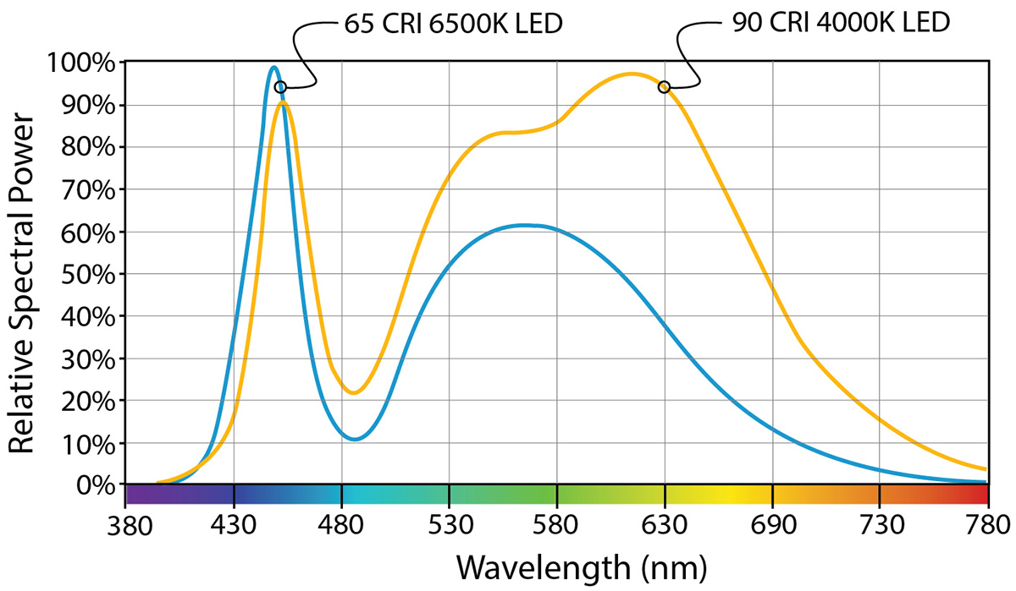219B 4000K LED and produces a maximum of 400 lumens.

## ANSI FL-1 Standard

Test performed with SuperFire 14500 LiIon cell. Light Output and run time will change based on what kind of battery you use.

## LED Tests

# Diagrams

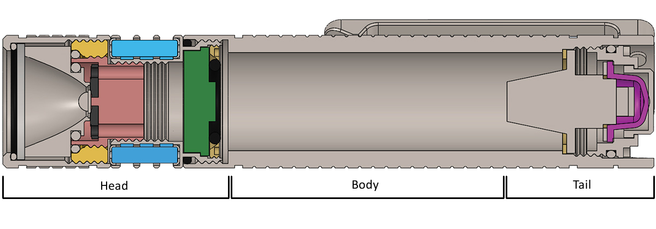

## Parts

|  |  |  |
| --- | --- | --- |
| **Index** | **Part** | **Size** (ID, OD, W) |
| a | Bezel |  |
| b | Lens O-ring | 16.5, 18, 1 |
| c | UCL Lens | na, 17, 1 |
| d | Reflector |  |
| e | Retainer/Reflector O-ring | 12.5, 14, 1 |
| f | Brass Retaining Ring |  |
| g | Retainer/Bezel O-ring | 18, 19.5, 1 |
| h | GTLS Retaining O-ring | 12.5, 14, 1 |
| i | GTLS dampening O-ring | 1.5, 2.5, 0.5 |
| j | GTLS or Steel Pin |  |
| k | LED |  |
| l | Copper Heat Sink |  |
| m | Heat Sink/Head |  |
| n | Head/Body O-ring | 17.5, 19, 1 |
| o | Driver |  |
| p | Driver Isolation O-ring | 8.5, 12.5, 2 |
| q | Button Switch Cap |  |
| r | Internal Switch Cap |  |
| s | Tail cap/Body O-ring | 14, 15.5, 1 |
| t | Tail cap/Button O-ring | 12, 13.5, 1 |
| u | Switch |  |
| v | Brass Interface Ring |  |
| w | Spring |  |
| x | T6 Torx Cap Screw |  |
| y | Tail Cap |  |
| z | Pocket Clip |  |

# Tips, Tricks and FAQ

## Installing Tritium (GTLS) Tubes

The firefly supports up to 8 GTLS (Gaseous Tritium Light Source) tubes which can be installed in the chambers in the cooling fins area. It supports 3x11mm tubes unprotected or 2.5x10mm tubes with the included shock dampening O-rings. If full size 3x11mm unprotected tubes are used, great care should be taken to avoid dropping the light. Even short drops have been observed to cause the full-sized tubes to rupture. 2.5x10mm tubes are recommended for this reason.

The tubes can be sourced from [mixglo.com](http://www.mixglo.com).

**Tools needed**

* Tweezers
* Needle or toothpick
* A clean working area

**Procedure**

1. Remove the head from the body
2. Remove the bezel from the head assembly. If the brass retaining ring separates from the bezel, see **Tips, Tricks and FAQ** for correcting this issue.
3. Use your toothpick to remove the GTLS retaining O-ring from the copper heat sink and place it aside.
4. Empty the chambers you wish to use.
5. Drop a shock dampener into an empty GTLS chamber, use the toothpick to push it to the bottom and lay it flat.
6. Place a shock dampener on the GTLS tube about 1mm down the body.
7. Drop the GTLS tube in the chamber with the installed dampener up.
8. Use the toothpick to carefully push the dampener into the top fin on all sides, this will squish the O-ring and create the retention needed for the GTLS tube.
9. With the O-ring in the fin, push the GTLS tube flush with the top fin. This may cause the O-ring to pop out under the first fin, between the first and second fins. If this happens use the toothpick to push the dampener back up into the first fin. If you can’t manage to reseat the O-ring into the first fin, remove the GTLS tube and start again with the O-ring installed higher on the GTLS tube body.
10. With the GTLS tubes installed, reverse the disassembly process; install the retaining O-ring, install the bezel to the head assembly, install the head to the body.

Josh produced a video showing the procedure here:   
<https://www.kickstarter.com/projects/2112614854/firefly-20-a-flashlight-you-can-always-find-in-the/posts/1601781>

**NOTE:** Josh neglected to re-install the GTLS retaining O-ring in the video. Don’t forget to re-install it.

## Stuck bezel retaining ring

Sometimes the reflector brass retaining ring comes out of the bezel and remains on the heatsink. You will need to gently remove the O-ring and retaining ring and replace them loosely into the bezel. You don’t want to tighten the retaining ring all the way down as the reflector is self-centering.

**Tools needed**

* Needle or toothpick

**Procedure**

1. Using the toothpick remove the O-ring in the center of the brass retaining ring.
2. Unscrew the brass retaining ring from the heat sink
3. Screw the brass retaining ring back into the bezel with the o-ring down.
4. Do not over-tighten the retaining ring, the reflector should still wiggle so that it can self-center upon assembly.
5. Drop the O-ring in the center of the brass retaining ring.
6. Using your toothpick push the O-ring down beyond the threads.
7. With the flashlight level (allow it to tail stand), screw the bezel assembly back on to the heat-sink. Tighten it down all the way.

Josh produced a video detailing this procedure here:  
<https://www.kickstarter.com/projects/2112614854/firefly-20-a-flashlight-you-can-always-find-in-the/posts/1623668>

## Crunchy tail switch

Several users complained that the tail switch in their firefly was “crunchy” or gritty and tended to bind up. One industrious CPF member helios123 [[post #313](http://www.candlepowerforums.com/vb/showthread.php?419969&p=4940432&viewfull=1#post4940432)] disassembled his tail section and polished the button cap, reporting this solved the problem. Josh reported there is an uncommon machining problem with a bur left in the channel which can be knocked out with a small file.

Upon disassembly, you may notice concentric machining marks on the button cap and tail cap channel. After polishing the cap and channel to a dull luster at 5000 grit and lubing the button and channel, the switch should be much smoother.

This procedure likely has 2 benefits, first the smoothing of the surfaces reduces friction and lockup in the channel, second the sanding ever so slightly widens the channel.

Alternatively, CPF user mk2rocco [[post #302](http://www.candlepowerforums.com/vb/showthread.php?419969&p=4939147&viewfull=1#post4939147)] was able to source a rubber tail cap for his firefly of size 13.6mm wide by 2mm tall base with a 10mm wide by 8mm tall button.

**Continued page 16**

**Crunchy tail switch continued…**

**Tools needed**

* 5/16” dowel
* High grit sandpapers, 800-5000 grit
* Forceps or small needle nose pliers
* T6 torx screwdriver
* Alcohol 90%+
* Cotton swabs
* Towels
* Grease
* Toothpick or needle

**Procedure**

1. Use your T6 screwdriver to remove the cap screws from the pocket clip. The screws are overly long and block the removal of the tail cap.
2. Using a pair of forceps or small needle nose pliers, place the jaws into two opposing half-moon cutouts on the tail cap. Gently turn counter clockwise until the tail cap frees. Once freed gently pry the tail cap out. Be careful, there is a small white plastic disc piece in the button switch cap that may fall out.
3. Disassemble the tail cap; using your toothpick remove the larger outer O-ring and the smaller inner O-ring, remove the switch cap from the tail cap, and locate the white plastic disc. Place all pieces to the side in an identifiable manner (don’t mix up the O-rings).
4. Using alcohol and cotton swabs & towels, clean the button switch cap and the tail cap.
5. For each piece of sand paper used, tear or cut a piece of sand paper off about ½ inch wide by 1-inch-long, for the dowel. You can use double sided tape to tape it to the 5/16” dowel.
6. Start out with the lowest grit, and move up to the highest. You may find automotive kits that contain 800, 1200, and 2000. There are also headlight repair kits that have 1000, 1500, 2000, and 2500. Also pick up a 5000 grit pad to finish. The 5000 grit may be used wet to achieve a dull luster (cloudy mirror like).
7. Using the sand paper, sand the sides of the button switch cap, the bottom flair, and the bottom of the button.
8. Using the dowel and scrap of sandpaper, sand inside the channel the switch cap sits in.
9. Move on after you see a uniform pattern, each step should remove more of the machine marks.
10. Between grits re-clean the surfaces with alcohol.
11. Thoroughly clean and dry the pieces with alcohol once complete.
12. Clean and lube the O-rings, using a toothpick gently re-seat the small O-ring inside the tail cap, then replace the large O-ring on the outside.
13. A very small dab of grease may be used to ‘stick’ the small plastic disc inside the button switch cap with the detent facing out.
14. Using a cotton swab, grease the channel the button switch cap sits in. Apply the grease in an even stroke from the base out the hole the button sits in. This will leave a slight film in the channel and collect a small bead of grease at the lip.

**Continued page 17**

**Crunchy tail switch continued…**

1. Using a cotton swab, grease the button switch cap. This time apply the grease in the opposite direction down towards the flair. This will leave a slight film on the button and collect a small bead of grease on the flair. The excess grease will squeeze out into the channel when reassembled.
2. Evenly lube the tail cap threads.
3. Place the button switch cap into the channel, and gently place the cap evenly on the body.
4. Using your toothpick stuff the O-ring into the body of the flashlight.
5. Try to even out the tail cap to prevent cross threading.
6. Using the jaws of your forceps or needle nose pliers placed in opposing half-moon cutouts, gently turn clockwise to screw it down. Keep going until you’ve cleared the tapped holes for the pocket clip screws. If you need excessive force to re-attach the pocket clip screws the tail cap isn’t screwed down far enough. If the tail cap binds or makes a grinding noise, it’s probably cross-threaded and needs to be backed out and re-seated. You may need to reseat the tail cap more than once.
7. Using your T6 torx screwdriver re-install the pocket clip.

## Titanium Splinters

CPF member Howiezowie [[post #351](http://www.candlepowerforums.com/vb/showthread.php?419969&p=4967051&viewfull=1#post4967051)] discovered his firefly still had machining debris on the body of his light in the form of miniscule titanium splinters. He unfortunately picked up these splinters with his fingers. He recommended disassembling the light and brushing the body of the light and threads to remove remaining debris.

**Tools needed**

* Latex or Nitrile gloves
* Nylon brush, such as an old toothbrush or gun cleaning blue bristle receiver brush
* Towel, micro fiber preferred
* Optional: disassembly tools
  + T6 torx screwdriver
  + Foreceps or needle nose pliers
  + Toothpick or needle
  + Grease

**Procedure**

1. Put on the gloves before handling your light to protect your hands.
2. Disassemble your light to your comfort level.
3. Outdoors or over your sink; take your brush and brush the entire body of the light vigorously.
   1. If you chose to disassemble your light, brush the threads as well.
4. Use your micro fiber towel to wipe down the light, the micro fiber will snag on any imperfections.
   1. If you chose to disassemble your light, wipe down the threads as well.
   2. If your light was disassembled, lube your threads prior to reassembly.

firefly  
beacon in the night